**To perform image filtering in spatial domain**

1. **: Box and Average Weighted Filter**

clc;

clearall;

closeall;

%Read Image

a=imread('C:\Users\Public\Pictures\Sample Pictures\Koala.jpg');

b=rgb2gray(a);

[r,c]=size(b);

figure

subplot(4,2,1)

imshow(a);

title('Input Colour Image');

subplot(4,2,2)

imshow(b);

title('Grayscale Image');

%Adding noise to image

e=imnoise(b,'salt& pepper',0.05);

subplot(4,2,3)

imshow(e);

title('Noisy Image');

g=double(e);

%Filter

w=[1 1 1 ; 1 1 1 ; 1 1 1]/9;

w1=[1 1 1 1 1 ; 1 1 1 1 1; 1 1 1 1 1; 1 1 1 1 1; 1 1 1 1 1]/25;

w2=[1 1 1 1 1 1 1 ;1 1 1 1 1 1 1 ;1 1 1 1 1 1 1 ;1 1 1 1 1 1 1 ;1 1 1 1 1 1 1 ;1 1 1 1 1 1 1 ; 1 1 1 1 1 1 1]/49;

w3=[1 2 1 ; 2 1 2 ; 1 2 1]/13;

%Applying Filter

fori=2:1:r-1

for j=2:1:c-1

f(i,j)= g(i-1,j-1)*w(1)+g(i-1,j)*w(2)+g(i-1,j+1)*w(3)+g(i,j-1)*w(4)+g(i,j)*w(5)+g(i,j+1)*w(6)+g(i+1,j-1)*w(7)+g(i+1,j)*w(8)+g(i+1,j+1)*w(9);

end

end

fori=3:1:r-2

for j=3:1:c-2

z(i,j)= g(i-2,j-2)*w1(1)+g(i-2,j-1)*w1(2)+g(i-2,j)*w1(3)+g(i-2,j+1)*w1(4)+g(i-2,j+2)*w1(5)+g(i-1,j-2)*w1(6)+g(i-1,j-1)*w1(7)+g(i-1,j)*w1(8)+g(i-1,j+1)*w1(9)+g(i-1,j+2)*w1(10)+g(i,j-2)*w1(11)+g(i,j-1)*w1(12)+g(i,j)*w1(13)+g(i,j+1)*w1(14)+g(i,j+2)*w1(15)+g(i+1,j-2)*w1(16)+g(i+1,j-1)*w1(17)+g(i+1,j)*w1(18)+g(i+1,j+1)*w1(19)+g(i+1,j+2)*w1(20)+g(i+2,j-2)*w1(21)+g(i+2,j-1)*w1(22)+g(i+2,j)*w1(23)+g(i+2,j+1)*w1(24)+g(i+2,j+2)*w1(25);

end

end

y=conv2(g,w2);

fori=2:1:r-1

for j=2:1:c-1

x(i,j)= g(i-1,j-1)*w3(1)+g(i-1,j)*w3(2)+g(i-1,j+1)*w3(3)+g(i,j-1)*w3(4)+g(i,j)*w3(5)+g(i,j+1)*w3(6)+g(i+1,j-1)*w3(7)+g(i+1,j)*w3(8)+g(i+1,j+1)*w3(9);

end

end

%Filtered image

subplot(4,2,4)

imshow(uint8(f));

title('3x3 Filtered Image');

subplot(4,2,5)

imshow(uint8(z));

title('5x5 Filtered Image');

subplot(4,2,6)

imshow(uint8(y));

title('7x7 Filtered Image');

subplot(4,2,7)

imshow(uint8(x));

title('3x3 Weighted Filtered Image');

OUTPUT

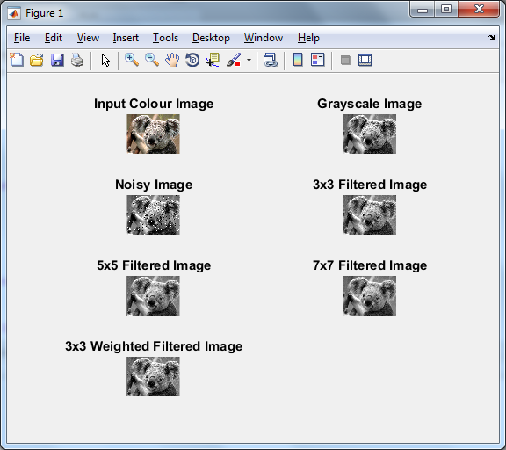

**(B)Median Filter Program :**

clc;

clearall;

closeall;

%Read Image

a=imread('C:\Users\Public\Pictures\Sample Pictures\Koala.jpg');

b=rgb2gray(a);

[r,c]=size(b);

figure

subplot(2,2,1)

imshow(a);

title('Input Colour Image');

subplot(2,2,2)

imshow(b);

title('Grayscale Image');

%Adding noise to image

e=imnoise(b,'salt& pepper',0.05);

subplot(2,2,3)

imshow(e);

title('Noisy Image');

g=double(e);

%Filter

w=[1 1 1 ; 1 1 1 ; 1 1 1]/9;

w1=[1 1 1 1 1 ; 1 1 1 1 1; 1 1 1 1 1; 1 1 1 1 1; 1 1 1 1 1]/25;

w2=[1 1 1 1 1 1 1 ;1 1 1 1 1 1 1 ;1 1 1 1 1 1 1 ;1 1 1 1 1 1 1 ;1 1 1 1 1 1 1 ;1 1 1 1 1 1 1 ; 1 1 1 1 1 1 1]/49;

w3=[1 2 1 ; 2 1 2 ; 1 2 1]/13;

%Applying Filter

fori=2:1:r-1

for j=2:1:c-1

p = [g(i-1,j-1) g(i-1,j) g(i-1,j+1) g(i,j-1) g(i,j) g(i,j+1) g(i+1,j-1) g(i+1,j) g(i+1,j+1)];

q=sort(p);

med=q(5);

u(i,j)=med;

end

end

%Filtered image

subplot(2,2,4)

imshow(uint8(u));

title('Median Filtered Image');

output:

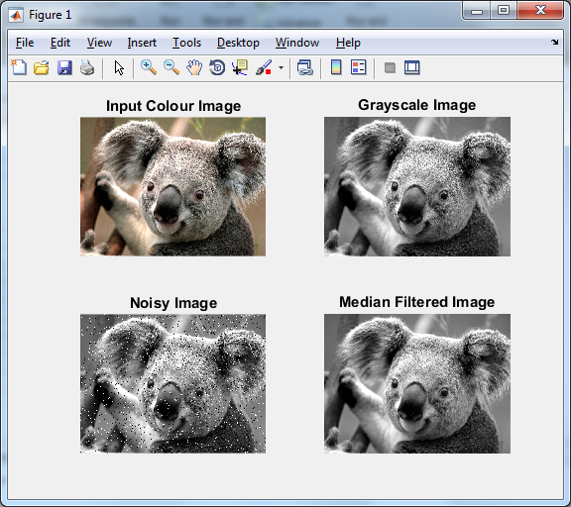

**© using high pass filtering (line mask)**

clc;

clearall;

closeall;

z=imread('C:\Users\Public\Pictures\Sample Pictures\Koala.jpg');

a=rgb2gray(z);

[R,C]=size(a);

for x=2:1:R-1

for y=2:1:C-1

t= a(x-1,y)+a(x,y-1)+a(x+1,y)+a(x,y+1)-4*a(x,y);

b(x,y)=t;

end

end

subplot(2,1,1);

imshow(a);

title('ORIGINAL IMAGE');

subplot(2,1,2);

imshow(b);

title('IMAGE AFTER APPLYING HIGH PASS');

OUTPUT:

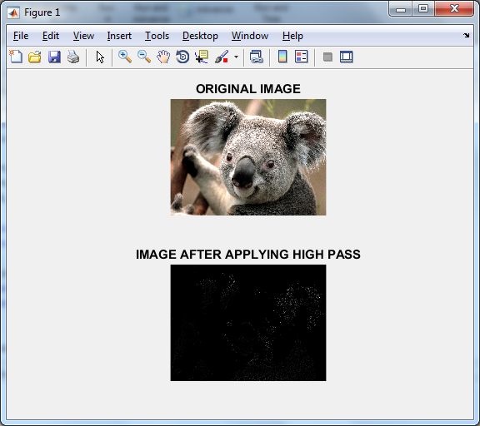

(d) **using high pass filter**

%HPF

clc;

clear all;

close all;

%Read Image

a=imread('C:\Users\akanksha\Pictures\Camera Roll\koala.jpg');

g=rgb2gray(a);

[r,c]=size(g);

figure

subplot(1,3,1)

imshow(g);

title('Grayscale Image');

%Filter

w=[-1 -1 -1 ; -1 9 -1 ; -1 -1 -1];

w1=[0 -1 0 ; -1 5 -1 ; 0 -1 0];

%Applying Filter

z=conv2(g,w);

y=conv2(g,w1);

%Filtered image

subplot(1,3,2)

imshow(uint8(z));

title('HPF 1');

subplot(1,3,3)

imshow(uint8(y));

title('HPF 2');

**OUTPUT :**

